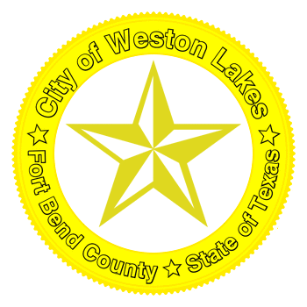
NOTICE of Virtual Special
City of Weston Lakes
Wednesday
January 13, 2021
11:00 AM
City Council Meeting

AGENDA: Special Council Meeting

Microsoft Teams meeting
Join on your computer or mobile app
Click here to join the meeting
Or call in (audio only)
+1 321-754-9478,,638333480# United States, Orlando
Phone Conference ID: 638 333 480#
Find a local number | Reset PIN

- Call to Order. Welcome everyone and thank you for attending our meeting.
- Ensure all council members have logged on successfully. Testing of O365 to ensure it is working properly and ensuring each member of our Board of Aldermen and the city secretary can sign on to the virtual platform. Ensure the microphone and cameras on each council members personal computers all work for the meeting.
- Invocation and Pledge of Allegiance
- Statement of public comments and public comments.
- Mayor’s comments
- Barry Ochsner with Alexaur to inform and address any concerns.
- Adjournment
CERTIFICATE: I, the undersigned, City Secretary of the City of Weston Lakes, do hereby certify that on the 7th day of January 2021, at or before 6:00 P.M., I posted a true and correct copy of the attached and following notice of a Public Hearing and City Council Meeting of the City of Weston Lakes City Council to be held on Wednesday, January 13th, 2021 at 11:00 A.M., virtually, which posting was done not less than three (3) full days prior to the date fixed for said meeting.

Signed ________________________________________________________________________
Jenni McJunkin, City Secretary

NOTICE Policy of Non-Discrimination on the Basis of Disability: The City of Weston Lakes does not discriminate on the basis of disability in the admission or access to, or treatment or employment in, its programs or activities.
NOTICE: The City of Weston Lakes reserves the right to adjourn into executive session at any time during the course of this meeting to discuss any of the matters listed above, as authorized by Texas Government Code Sections 551.071 (Consultation with Attorney), 551.072 (Deliberations about Real Property), 551.073 (Deliberations about Gifts and Donations), 551.074 (Personnel Matters), 551.076 (Deliberations about Security Devices) and 551.086 (Economic Development).

